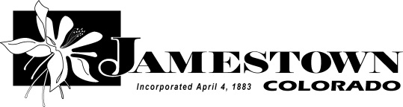
Confidentiality Agreement – Jamestown Volunteer
I, the undersigned, in consideration of my participation as a volunteer with Jamestown, hereby agree to the following Confidentiality Agreement.
I understand that I may be given access to confidential and/or proprietary information to the extent necessary in order to perform my duties as a volunteer with Jamestown. I shall not, at any time either during or subsequent to this participation with Jamestown, make unauthorized disclosures or unauthorized use of any information that is considered to be proprietary or confidential by Jamestown. Proprietary information includes, but is not limited to, all information, data, reports, analyses, processes, know-how, designs, plans, marketing data, business plans and strategies, negotiations and contracts, research, and volunteer, donor or vendor lists, compilations, trade secrets, and confidential information, whether in written, oral or electronic form. Confidential information includes, but is not limited to, any personal information of any Jamestown employee, volunteer, agency partner, or donor, whether in written, oral or electronic form.
All employer records and information relating to Jamestown or its volunteers, agency partners, and donors are confidential and I will treat all matters accordingly. This includes any information protected under any applicable state or federal privacy law. No Jamestown-related information, including without limitation, documents, notes, files, records, oral information, computer files or similar materials (except in the ordinary course of performing duties on behalf of Jamestown) may be removed from Jamestown premises without permission from Jamestown staff. Additionally, the contents of Jamestown’s records or information otherwise obtained in regard to business may not be disclosed to anyone, except where required for an authorized business purpose and/or required by law. I will not disclose any confidential information, purposefully or inadvertently (through casual conversation), to any unauthorized person inside or outside Jamestown. If I am unsure about the confidential nature of specific information, or whether specific information may be protected under state or federal law, I will ask the Jamestown staff member supervising my actions as a project for clarification before disclosing the information.
Proprietary information and trade secrets are created at substantial cost and expense to Jamestown. Unauthorized use or disclosure of confidential or proprietary information would cause irreparable injury to Jamestown. I agree that monetary damages would not be a sufficient remedy for any breach of this agreement by me, and that, in addition to all other remedies, Jamestown shall be entitled to seek (a) specific performance and (b) injunctive or other equitable relief as a remedy for any such breach, and I further agree to waive any requirement for any bond in connection with such remedy.
When I cease my participation as a volunteer with Jamestown, I will return all Jamestown-related information and property that I have in my possession, including without limitation documents, files, records, manuals, information stored on a personal computer, personal data assistant or computer disk, supplies, and equipment or office supplies.
Printed Name: ______________________________________________ Signature:__________________________________________________. Date: _____________________

